1.) Suppose you have trained an SVM classifier with a Gaussian kernel, and it learned the following decision boundary on the training set:

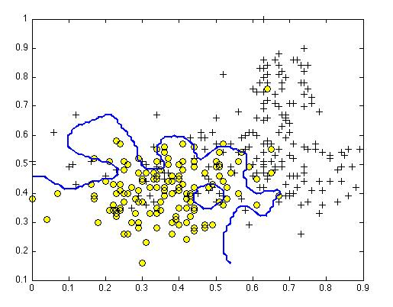

When you measure the SVM's performance on a cross validation set, it does poorly. Should you try increasing or decreasing C? Increasing or decreasing σ2?

* It would be reasonable to try **decreasing** C. It would also be reasonable to try **increasing** σ2.

2.) The formula for the Gaussian kernel is given by similarity(x,l(1)) = exp(−||x−l(1)||22σ2) . The figure below shows a plot of f1=similarity(x,l(1)) when σ2=1.

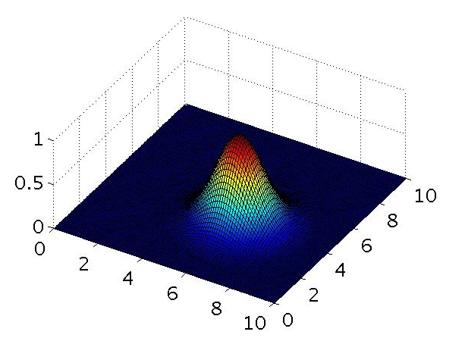

Which of the following is a plot of f1 when σ2=0.25?

* 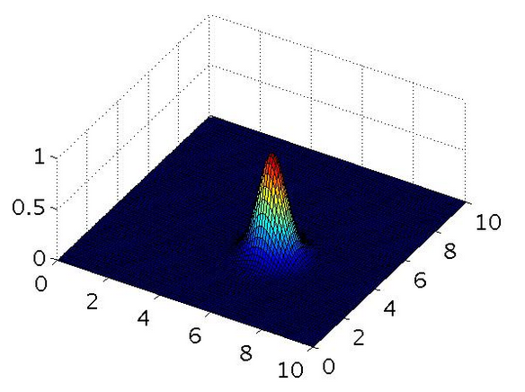

3.) 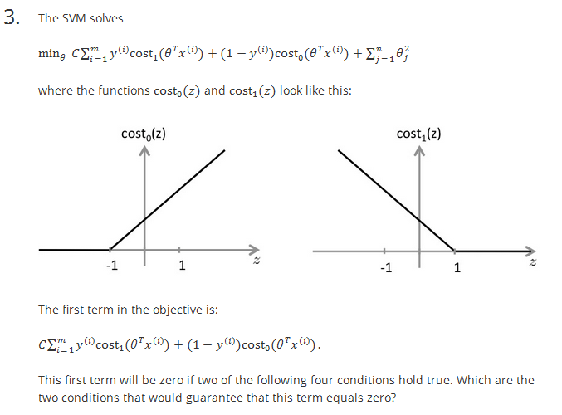

- For every example with y(i)=1, we have that θTx(i)≥1.

- For every example with y(i)=0, we have that θTx(i)≤−1.

4.) Suppose you have a dataset with n = 10 features and m = 5000 examples.

After training your logistic regression classifier with gradient descent, you find that it has underfit the training set and does not achieve the desired performance on the training or cross validation sets.

Which of the following might be promising steps to take? Check all that apply.

* Create / add new polynomial features. ??? not sure

5.) Which of the following statements are true? Check all that apply.

- The maximum value of the Gaussian kernel (i.e., sim(x,l(1))) is 1.

- Suppose you have 2D input examples (ie, x(i)∈R2). The decision boundary of the SVM (with the linear kernel) is a straight line.